Phase-2 Research Report
Data-Backed Milling Tool-Life Equation and Simulation Engine
Prepared on 2026-04-14
This report summarizes the phase-2 research workflow built from the NUAA orthogonal milling bundle, the PHM 2010 milling challenge dataset, and the NASA milling dataset. The objective was to derive a data-backed analytical wear equation that can be inverted into a practical tool-life simulator.

1. Executive Summary
- The fitted early-stage wear exponent is 0.6347 on NUAA and 0.6471 on PHM 2010, which justifies the selected operating value of 0.64.
- The fitted late-stage wear exponent on the NASA run-to-failure traces is 1.2873, supporting an accelerated end-of-life regime.
- The derived condition term is dominated by feed sensitivity (3.956), followed by depth (0.688); spindle-speed sensitivity is weaker (0.360) in the available data range.
- The selected final model is piecewise rather than single-regime: early wear is sub-linear in time, while late wear accelerates.
- A closed-form simulator was implemented so tool life can be predicted analytically for any target wear threshold once a calibration factor is chosen.

2. Data Base Used
Three public milling datasets available in the local workspace were used for complementary roles: NUAA to identify the process-parameter law, PHM 2010 to verify the early-regime exponent on a second milling source, and NASA to identify the accelerated late wear regime.
dataset | series_count | total_points | min_wear_mm | max_wear_mm | max_time
NASA | 16 | 146 | 0.00 | 1.53 | 105.00
NUAA | 9 | 152 | 0.06 | 0.31 | 55.40
PHM2010 | 3 | 945 | 0.02 | 0.22 | 315.00

3. Selected Equation
Condition intensity:
phi = (speed_rpm / 1800)^0.3600 * (feed_mm_tooth / 0.05)^3.9560 * (depth_mm / 3.0)^0.6881
Early regime (VB <= 0.25 mm):
VB(t) = VB0 + lambda * 0.01858 * phi * t^0.64
Late regime (VB > 0.25 mm):
VB(t) = 0.25 + lambda * rho * 0.01858 * phi * (t - t0.25)^1.29
This structure was selected because forcing a single exponent over the full milling life cycle underfits the early stage and misrepresents end-of-life acceleration. The transition wear of 0.25 mm is treated as the regime boundary.
item | value | notes
NUAA early exponent | 0.6347 | Run-level fit on orthogonal milling experiments
PHM early exponent | 0.6471 | Cut-level fit on PHM 2010 cutter wear traces
NASA late exponent | 1.2873 | Case-level fit on measured wear points
Selected early exponent | 0.6400 | Rounded operating value for simulator
Selected late exponent | 1.2900 | Rounded operating value for simulator
Early k coefficient | 0.0186 | Minutes-based NUAA condition law
Speed exponent | 0.3600 | Condition-intensity term around 1800 rpm
Feed exponent | 3.9560 | Condition-intensity term around 0.05 mm/tooth
Depth exponent | 0.6881 | Condition-intensity term around 3.0 mm axial depth

4. Fitted Wear Curves
The figures below show how the selected power-law family tracks the measured wear trajectories in each dataset role.
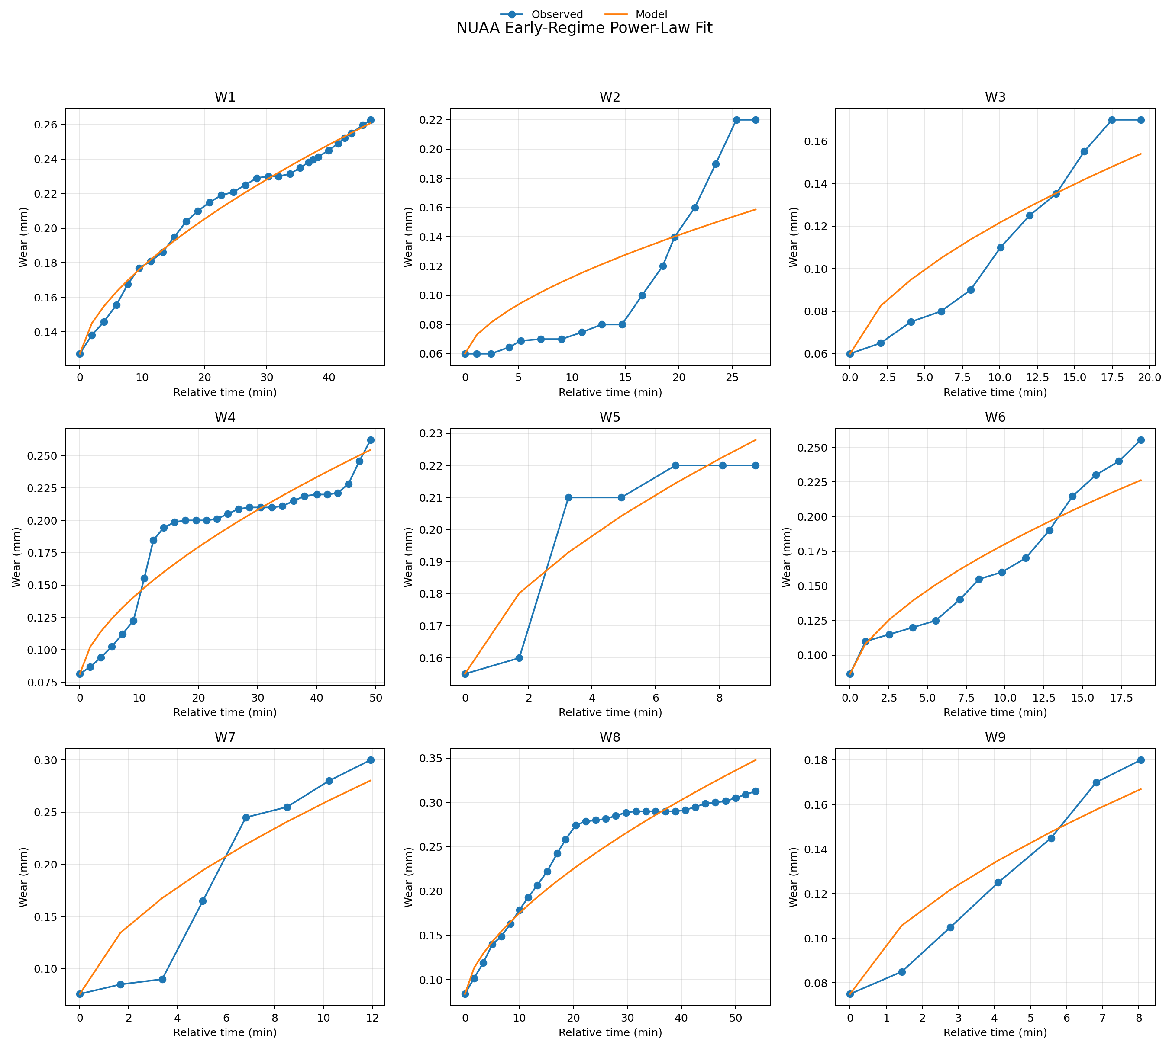
Figure 1. NUAA early-regime fit used for the condition law.
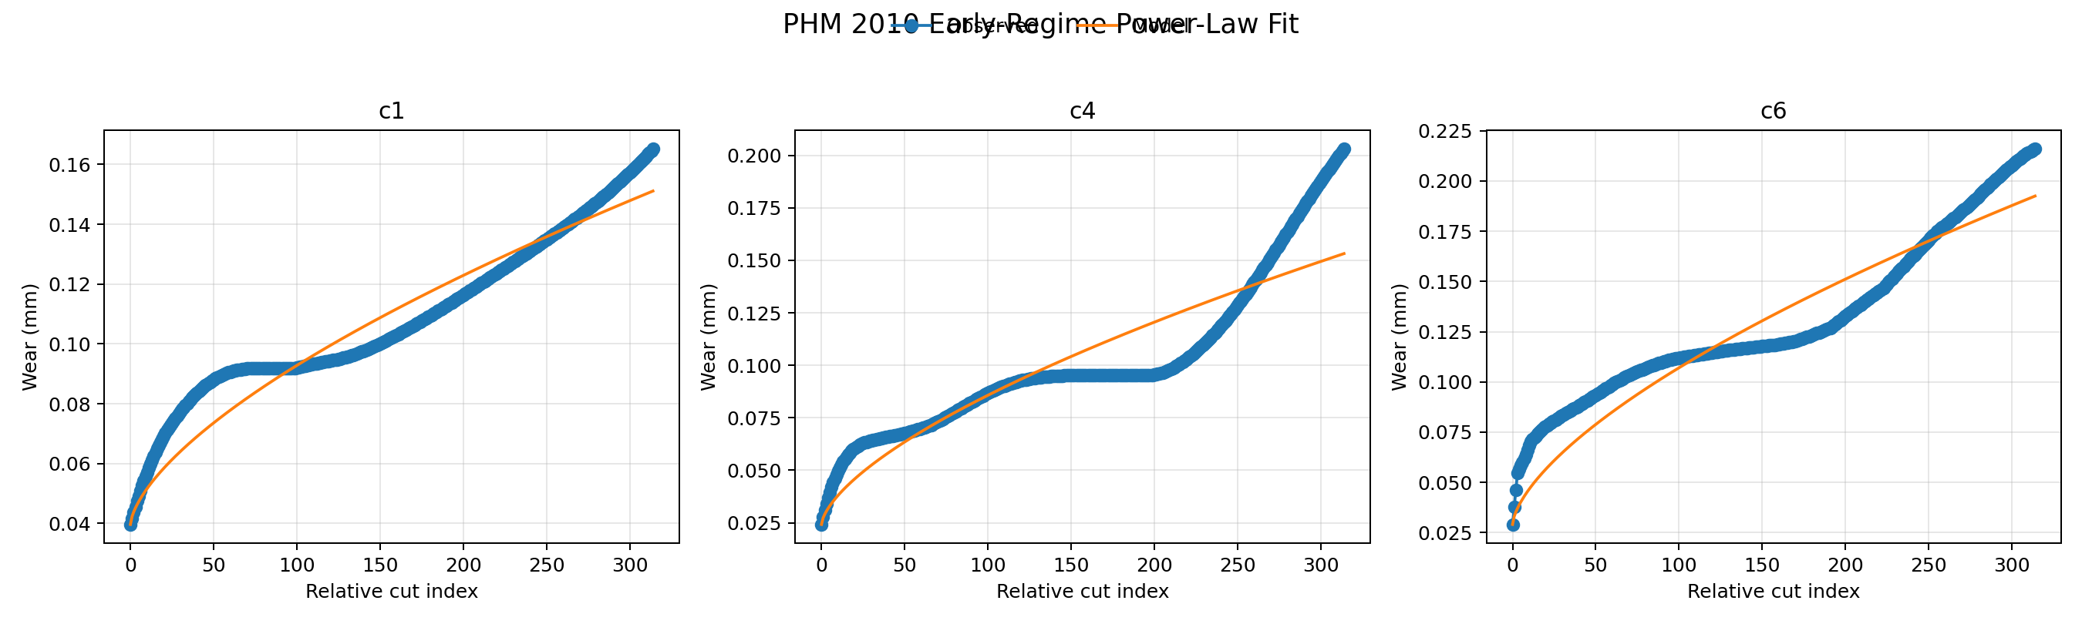
Figure 2. PHM 2010 fit used to confirm early-regime behavior.
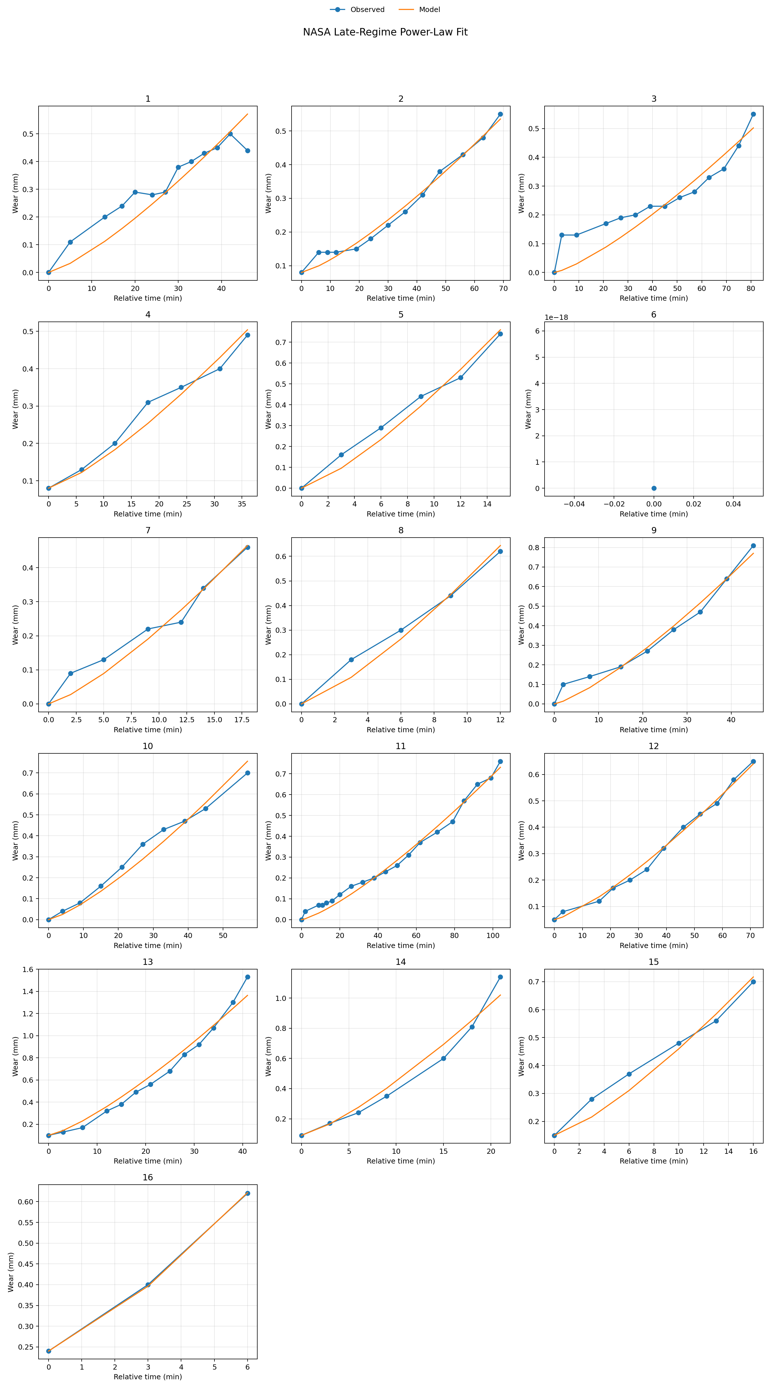
Figure 3. NASA fit used to identify late-stage acceleration.

5. Deeper Validation
A deeper validation layer was added beyond the original phase-2 fit: bootstrap stability of the exponents, leave-one-experiment-out benchmarking against machine-learning baselines, and material-family analysis of late-stage acceleration.
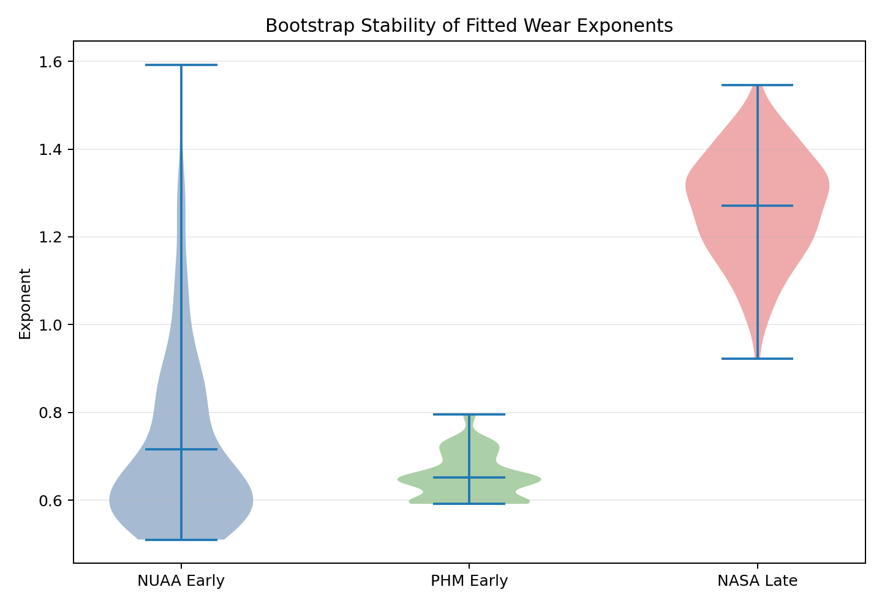
Figure 4. Bootstrap distribution of early and late fitted exponents.
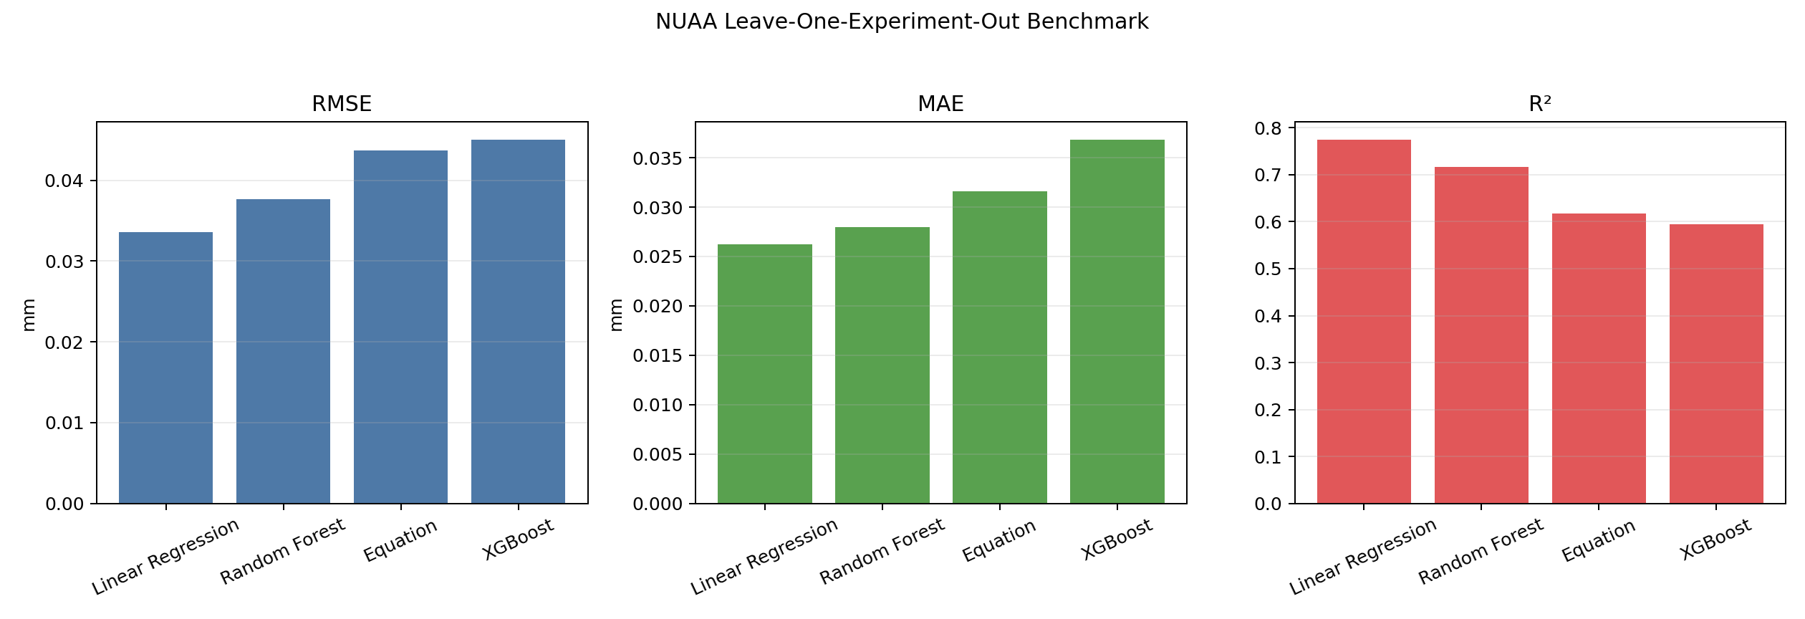
Figure 5. NUAA leave-one-experiment-out benchmark across interpretable and ML models.
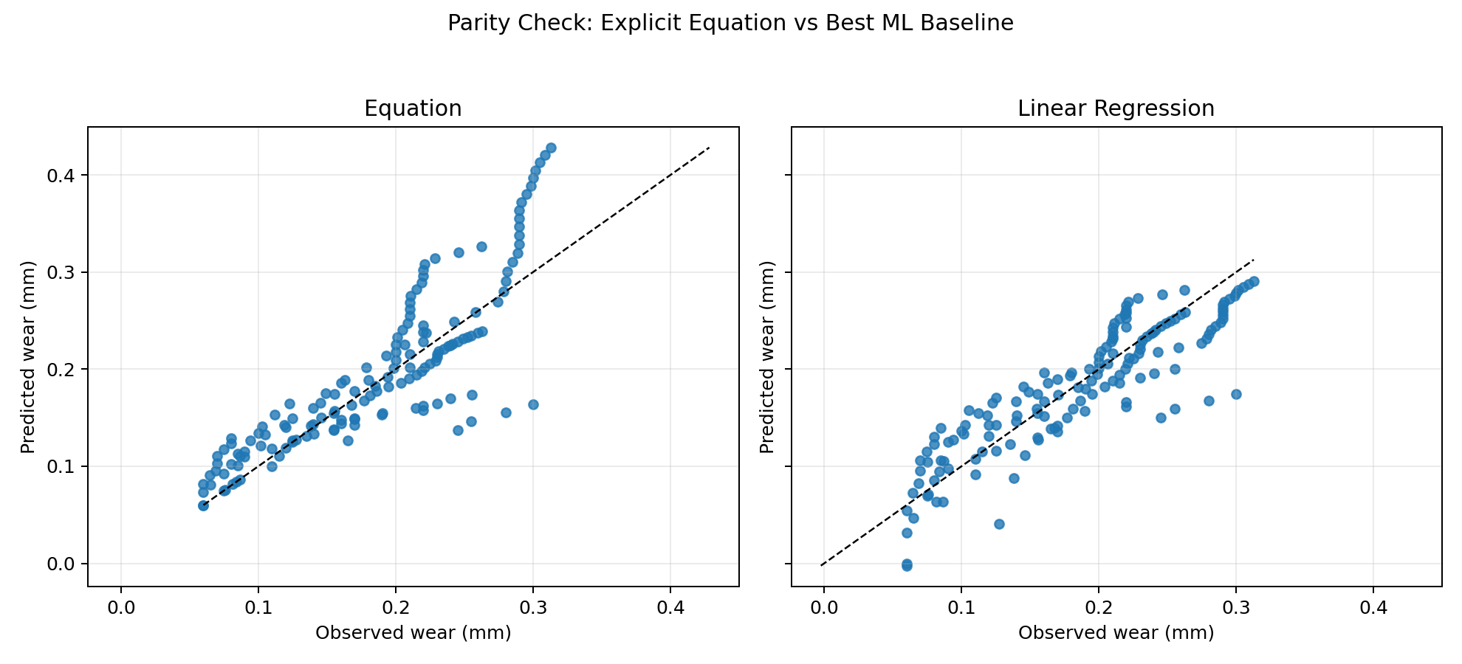
Figure 6. Parity comparison of the explicit equation and the best ML baseline.
model | rmse_mm | mae_mm | r2
Linear Regression | 0.0336 | 0.0262 | 0.7742
Random Forest | 0.0376 | 0.0280 | 0.7164
Equation | 0.0437 | 0.0316 | 0.6174
XGBoost | 0.0450 | 0.0368 | 0.5946
Interpretation: the explicit equation is not the numerically best pointwise predictor on held-out NUAA trajectories; a plain linear regression achieves lower error in this benchmark. However, the explicit equation remains the preferred phase-2 model because it is analytically invertible, exposes the machining parameters directly, and can be used as a simulation engine rather than only as a black-box regressor.
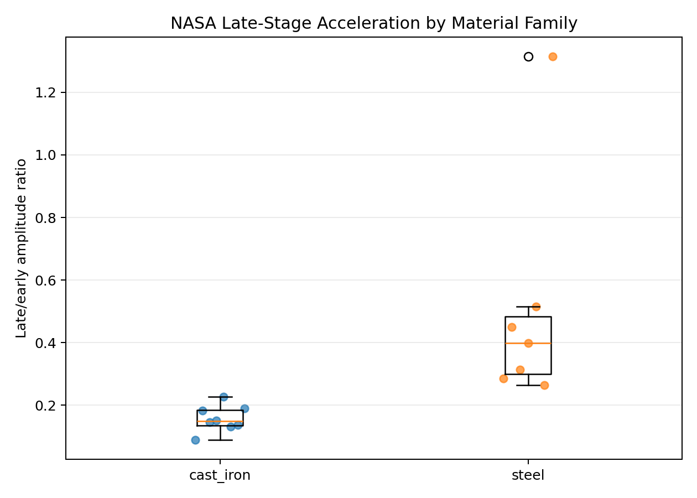
Figure 7. Late-stage acceleration ratio grouped by material family in the NASA dataset.
material_family | count | mean | median | std | min | max
cast_iron | 8 | 0.1568 | 0.1488 | 0.0423 | 0.0886 | 0.2268
steel | 7 | 0.5062 | 0.3994 | 0.3681 | 0.2636 | 1.3148

6. Simulator Behavior
The simulator was built on top of the selected piecewise equation. The baseline example below corresponds to speed = 1800 rpm, feed = 0.05 mm/tooth, depth = 3.0 mm, initial wear = 0.05 mm, threshold = 0.30 mm, and calibration factor = 1.0.
- Predicted generic baseline life: 47.28 min
- Predicted cast-iron baseline life: 50.40 min
- Predicted steel baseline life: 45.36 min
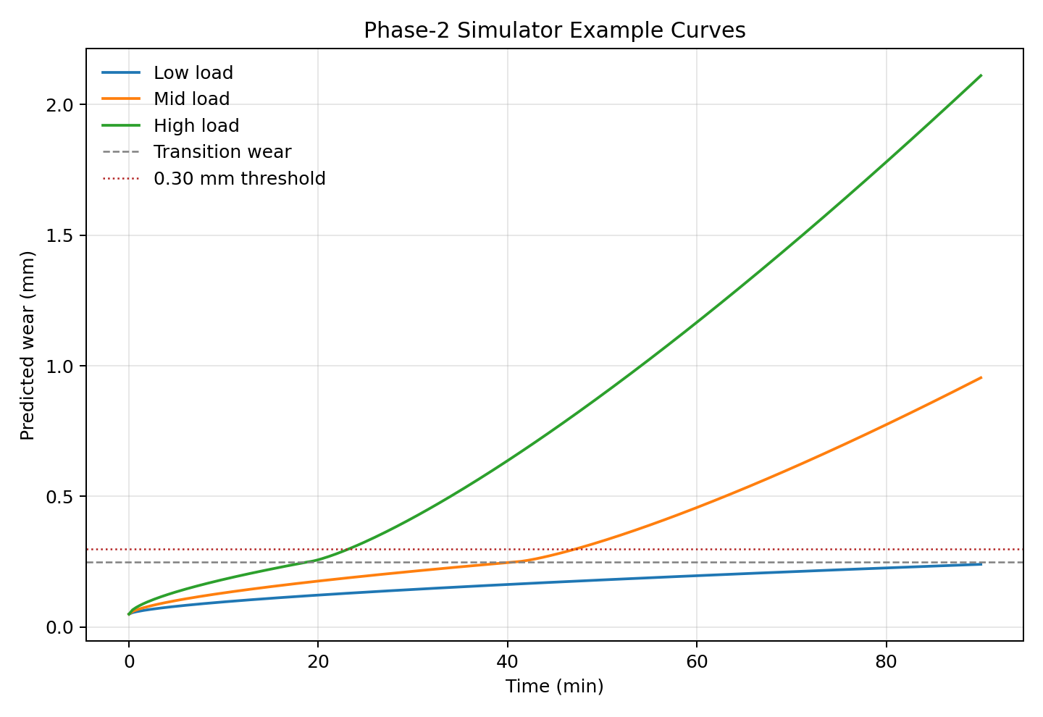
Figure 8. Example simulated wear curves under low, medium, and high load.
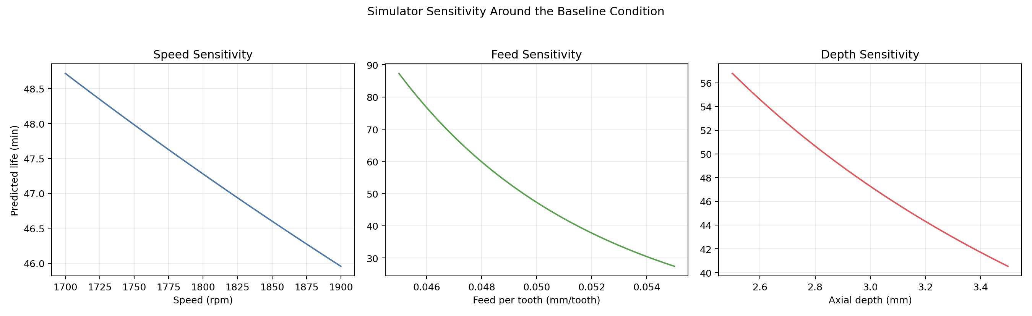
Figure 9. Predicted tool-life sensitivity around the baseline condition.

7. Findings
- The most stable observation across datasets is the existence of two wear regimes rather than one universal Taylor-like regime.
- Feed per tooth is the strongest driver in the fitted early condition law. Within this dataset family, increasing feed rapidly shortens life.
- Depth of cut has a clear but secondary influence. Spindle speed is less identifiable because the NUAA speed range is relatively narrow.
- Late-stage acceleration differs strongly by material family in the NASA cases, so a single absolute post-threshold constant is not justified.
- The explicit equation is best suited as a hybrid engineering model: interpretable, calibratable, and analytically invertible.

8. Limits and Recommended Next Work
- Collect a wider spindle-speed sweep under otherwise fixed conditions. This is the cleanest way to stabilize the speed exponent.
- Add true run-to-failure data at the same parameter grid used for the early-regime fit. That would remove the current split between NUAA/PHM early evidence and NASA late evidence.
- Estimate the calibration factor lambda separately for each tool-workpiece pair before using the simulator in production planning.
- If maximum predictive accuracy is the only objective, keep a parallel ML baseline. If interpretability and simulation matter, keep the explicit equation as the main model.

9. References
- PHM Society. 2010 PHM Society Conference Data Challenge. https://phmsociety.org/phm_competition/2010-phm-society-conference-data-challenge/
- NASA Ames / UC Berkeley. Documentation for Mill Data Set. Local copy used from data/nasa_milling/Readme.pdf.
- Piecuch, G., & Żabiński, T. (2025). A new open dataset from a milling process – data for classification and estimation of tool life. Scientific Data, 12, 650. https://www.nature.com/articles/s41597-025-04923-y
- Paszkiewicz, A. et al. (2023). Estimation of Tool Life in the Milling Process—Testing Regression Models. Sensors, 23(23), 9346. https://doi.org/10.3390/s23239346

Appendix: Output Inventory
Primary generated artifacts are stored in the phase-2 output directory: coefficients JSON, CSV tables, plots, and this Word report.

